|  |
| --- |
| CPD Record |
| Large rock formation in rocky landscape under blue sky |

|  |  |
| --- | --- |
| 28/03/19 | Continuous Professional Development |

This is a record of my Continual Professional Development

CPD Record

Continuous Professional Development

### When it was completed

### What I did

### What I found difficult

### What I created

### How I have applied it

Team TreeHouse Online courses

### Courses Completed

* How the Internet Works
* How the Web Works
* How to Make a Website
* Bootstrap 4 Basics
* HTML Basics
* HTML Forms
* HTML Tables
* HTML Video and Audio
* Responsive Images
* Web Accessibility Compliance
* CSS Basics
* CSS Layout Basics

I have been working my way through several online course provided by Team Treehouse, an online learning provider that specialise in technology education. The courses were thorough and easy to digest, but at the start of my course I did struggle for time to complete them, and found that I would forget the information if I didn’t use it continuously for a few weeks and would have to skim the contents of the course again to try and keep the information fresh in my head.

As part of the courses I created several small websites and webpages using the skills learnt in the course. For example, for the Bootstrap 4 Basics course I created a page for a [Full Stack Conference](http://www.code-ine.website/fullstack/). Over the courses I learnt a lot about good practice for coding and making pages responsive and accessible, and not just the code aspect of work.

All the work that I created can be found on my site [www.code-ine.website](http://www.code-ine.website/), along with snippets of the code on [CodePen.io](https://codepen.io/Stuart-White/).

I have used what I learnt here to create a solid foundation for my own self-guided learning, being able to expand on concepts that were introduced in these courses.

GDI Javascript

[Introduction to JavaScript](http://girldevelopit.github.io/gdi-featured-js-intro/#/) is a course I found on GitHub that is created by Girl Develop It. I started this course in September of 2018 and completed it over several weeks.

The course entailed a series of slides, broken up into sessions, that covered several concepts in JavaScript with challenges at the end of each, where you could input the code you had been learning about and then were encouraged to change it so that you could see how it would affect the outcome. There was also ‘Homework’ to be completed too, these were challenges where you could pull all the information from a session and were then asked to create a piece of code that fulfilled the requirements.

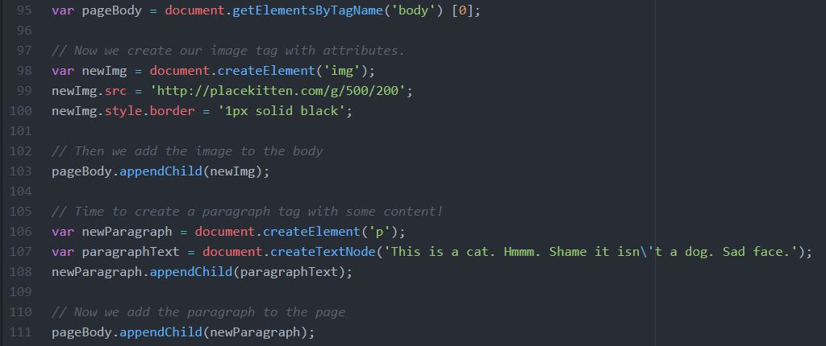

Figure 1 – Segment of code I wrote for one of the challenges



Figure 2 - Output from the code

Similar to the Team Treehouse tutorials, I found it difficult to retain the information unless I was using it on a day to day basis and so had to occasionally recap what I had learnt previously.

I have used the knowledge gained from this course as a foundation for further self-guided learning and in several pieces of work that I have been asked to do.

Agile in a Day course at Happy LtD

I took this course on the 20th February at Happy Ltd, the course was an introduction to Agile in project management and how it can be applied to other work flows. It covered the history of not just Agile, but other project management styles.

The course started with the history of project management and what a project was. This started with how project management became a recognised and applicable idea from the AACE (Association for the Advancement of Cost Engineers) in the 1950’s to help them deliver projects on time and on budget, and gave us a brief but comprehensive development of the industry and the various standards used.

The trainer then went on to explain how Agile came about, from the group of software developers who came up with the idea, and where these concepts originally came from in different work flow methodologies around the world, how these ideas were pulled together to create the Agile method. The trainer talked about how it developed and then flourished in the Software Development sector, and then how companies tried to apply it to Project Management.

Once the background had been covered, the trainer went on to explain in detail what the Agile method was, how it is applied to software development, and how it can be applied to other industries. He explained the flow of information and the key tenets behind the ideas. We worked through examples that the trainees on the course had, either at work or had thought of, and how you can apply the Agile method to these examples. We created user stories for the examples, and evaluated them using MoSCoW (Must Have, Should Have, Could Have, Want to Have) to be able to deliver a minimum viable product, we looked at Kanban boards and how they can be used to help your work flow. We also looked at identifying key stakeholders and their place within the flow of information.

It was a very comprehensive course that was easy to understand, the trainer explained everything clearly and was not hesitant to field questions from the trainees throughout the day. Having taken the course I was able to implement Agile in my projects in a more effective manner, now that I had a clearer understanding of the process.

I have been using Agile now in the planning and implementation of my projects in a much more effective manner, creating user stories and understanding the importance of keeping the stakeholders involved at every stage of the process as well as keeping them updated through a project. The iterative nature of Agile has allowed my work to adapt as the project has progressed, meaning that the work at every stage of the process has been inline with what the clients and users want, and I have been able to verify this through continual testing.

While I haven’t implemented Scrum into my work style, I do understand how this could be useful and allow for teams to work more efficiently and have greater communication during a project.